# EXIT Result of Lab:

Restart Listener:

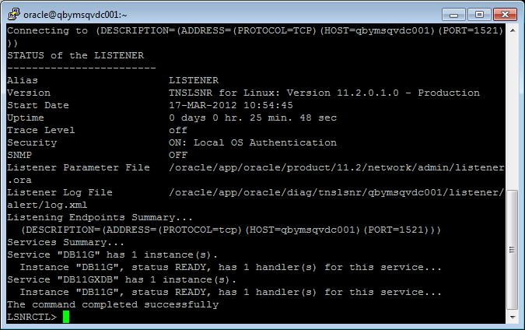

Start Oracle Database Instance:

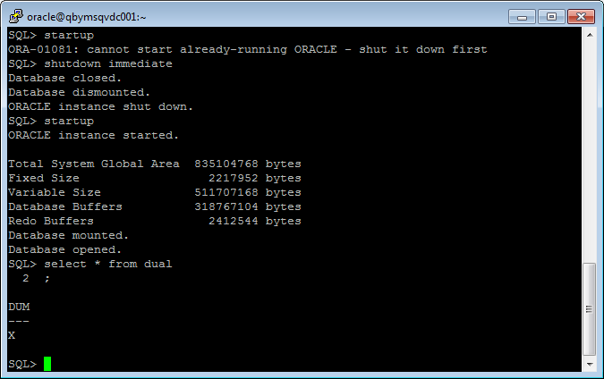

Restart Enterprise Manager:

